DT-30/03/2020

Use full links for python strings and examples

Floating point numbers - [Floating Point Numbers - Computerphile](https://www.youtube.com/watch?v=PZRI1IfStY0)

PYTHON MATH FUNCTIONS

<https://www.programiz.com/python-programming/modules/math>

Python documentation

<https://docs.python.org/3/>

Precedence and associativity

<https://www.programiz.com/python-programming/precedence-associativity>

<https://docs.python.org/3/reference/expressions.html>

Base number

<https://www.geeksforgeeks.org/python-int-function/>

Python key words

<https://www.w3schools.com/python/python_ref_keywords.asp>

Keywords and expression

<https://www.pythonforbeginners.com/basics/keywords-in-python>

Functions

<https://docs.python.org/3/library/functions.html>

String strings

<https://www.w3schools.com/python/python_ref_string.asp>

Guide

<https://realpython.com/python-comments-guide/>

Booleans

<https://problemsolvingwithpython.com/04-Data-Types-and-Variables/04.02-Boolean-Data-Type/>

Builtin methods

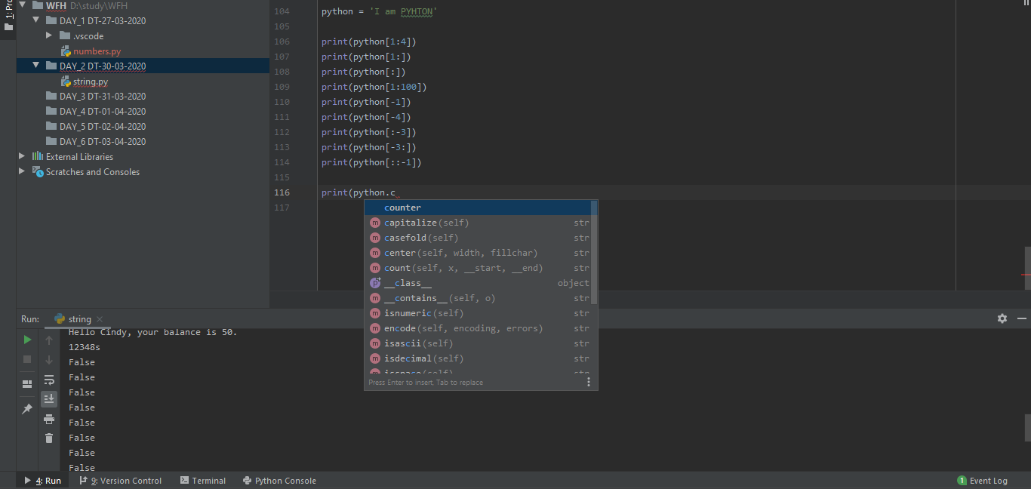

Python lists

<https://www.w3schools.com/python/python_lists.asp>

<https://www.geeksforgeeks.org/python-list/>

<https://www.programiz.com/python-programming/list>

DT-31/03/2020

Python lists in matrices

<https://www.w3schools.in/python-data-science/matrices-in-python/>

<https://www.geeksforgeeks.org/python-using-2d-arrays-lists-the-right-way/>

<https://www.geeksforgeeks.org/multi-dimensional-lists-in-python/>

<https://www.programiz.com/python-programming/matrix>